
MACFLO SLIDE VALVE

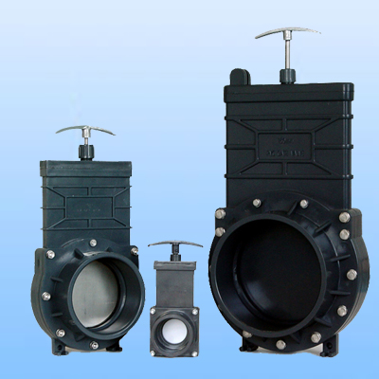
PVC Gate Valve

Please turn over page for Spec Sheet
Description:  - Size: 1 1/4’’-6’’(DN32-DN150)  - Standard: DIN,ANSI,BS  - Material: UPVC  - Working Pressure: 0.35mpa  - Widely used in effluent applications. | 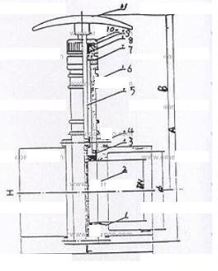

Materials of Construction
No. | Parts | Material
1 | Faucet | UPVC
2 | Valve Gate | PP, 1Cr13
3 | Seat | EPDM,NBR
4 | Bolt | A2
5 | Stem | 1Cr13
6 | Body | UPVC
7 | Cap | UPVC
8 | O-Ring | EPDM,NBR
9 | Bushing | UPVC
10 | Key | UPVC
11 | Handle | ABS,ZL106

Dimension
Size | A | B | DN | Φ | L | H | PN
mm(in) |  |  |  |  |  |  | (Mpa)
1 1/4'' | 143 | 115 | 32 | 40 | 68 | 57 | 0.35
1 1/2'' | 170 | 136 | 40 | 50 | 100 | 74 | 0.35
2'' | 207 | 163 | 50 | 63 | 108 | 86 | 0.35
2 1/2'' | 240 | 190 | 65 | 75 | 125 | 104 | 0.35
3'' | 305 | 222 | 80 | 90 | 128 | 150 | 0.35
4'' | 350 | 260 | 100 | 110 | 132 | 170 | 0.35
6'' | 505 | 380 | 150 | 160 | 172 | 242 | 0.35

